Adding SubForms to Grants.gov Application
- On your application form page, click the box next to the R&R Subaward hyperlink
- Then click on Go To Subforms
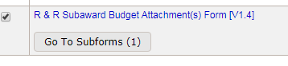
- Enter the subaward name, click Save
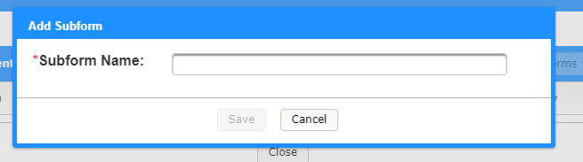
- Click the Download link and save the file to your desktop. Send to the subawardee to fill out. Or, add them as a participant and they can fill out the on-line Webform.
