Invoicing on ASAP (Automated Standard Application for Payments)
LOG ON SCREEN
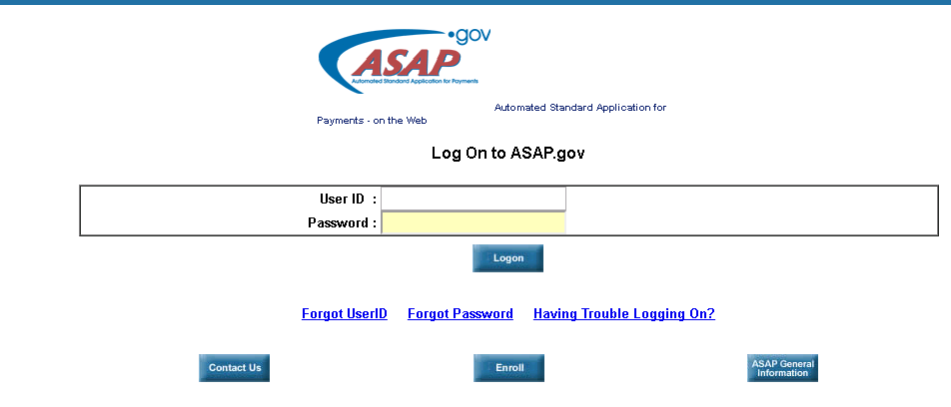
HOME PAGE
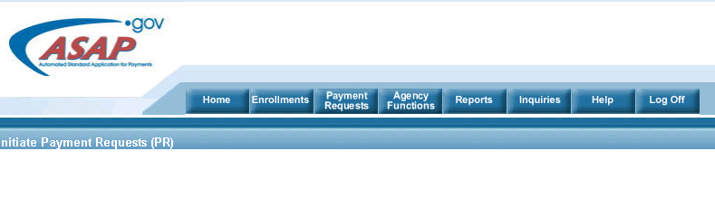
- Click on Payment Requests
- Click on Initiate Payment Requests (PR)
- The banking information should be setup prior to invoicing
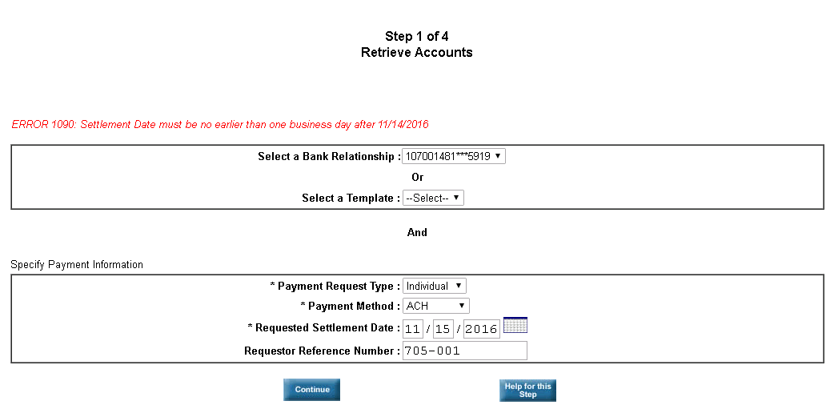
- Select Bank (there is probably only one)
- Request type is Individual
- Payment method is usually ACH
- The settlement date is the next business day
- Click Continue
- Leave the next screen blank
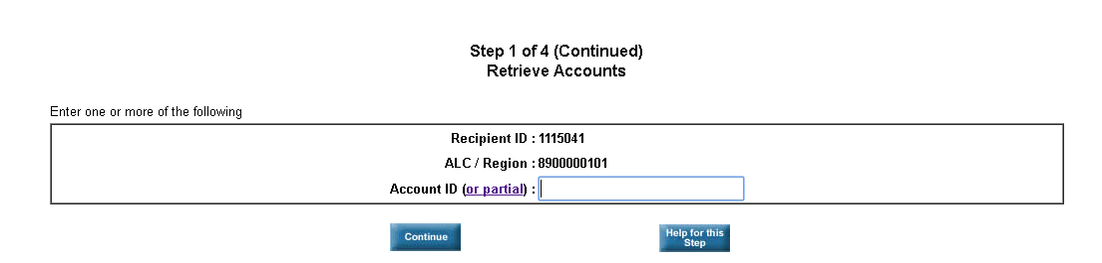
- You will see the available balance
- Enter the amount you want to invoice next to Total
- Use the Requestor Reference Number field to enter our invoice number
- Click on Continue
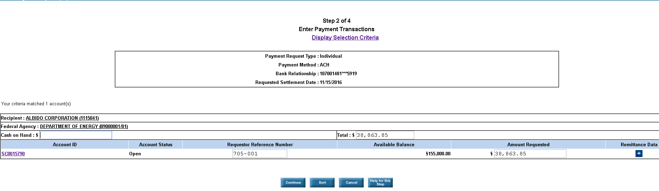
- Click on Submit
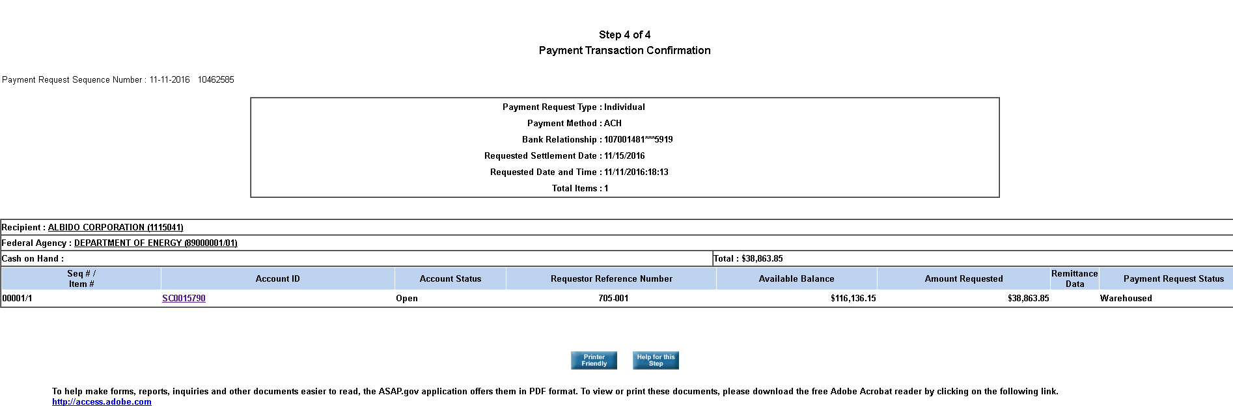
- You will now see that the available balance of the grant has been updated.
- Click on Printer Friendly to download the receipt
